USB NIC

🔌 What is a USB NIC (Network Interface Card)?
# Source: Chatgpt (GPT‑5 Mini) at [12/18/2025]
A USB NIC is a network adapter that connects to a computer via a USB port and provides network connectivity, either wired (Ethernet) or wireless (Wi-Fi). It's an external version of a regular NIC and is especially useful for devices without built-in network ports.
✅ A USB NIC gives your laptop or desktop the ability to connect to a network through USB — often used when a built-in NIC is missing, damaged, or needs upgrading.

📦 Types of USB NICs
# Source: Chatgpt (GPT‑5 Mini) at [12/18/2025]
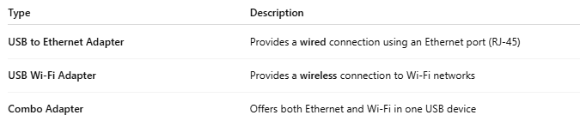

Type | Description
USB to Ethernet Adapter | Provides a wired connection using an Ethernet port (RJ-45)
USB Wi-Fi Adapter | Provides a wireless connection to Wi-Fi networks
Combo Adapter | Offers both Ethernet and Wi-Fi in one USB device

🔧 Key Features
# Source: Chatgpt (GPT‑5 Mini) at [12/18/2025]
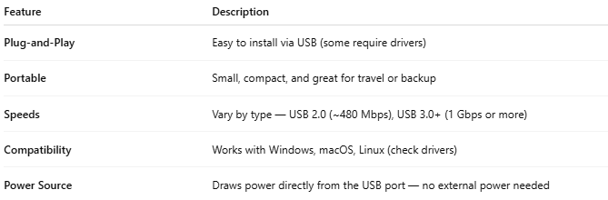

Feature | Description
Plug-and-Play | Easy to install via USB (some require drivers)
Portable | Small, compact, and great for travel or backup
Speeds | Vary by type — USB 2.0 (~480 Mbps), USB 3.0+ (1 Gbps or more)
Compatibility | Works with Windows, macOS, Linux (check drivers)
Power Source | Draws power directly from the USB port — no external power needed

🧱 Use Cases
# Source: Chatgpt (GPT‑5 Mini) at [12/18/2025]
- 💻 Laptops without Ethernet ports (e.g., ultrabooks)
- 🧩 Desktop PCs needing an extra NIC
- 🛠️ Replacing a damaged built-in NIC
- 🌐 Adding dual-homing (two network interfaces) for redundancy
- 📡 Connecting a PC to Wi-Fi if it lacks built-in wireless

✅ Advantages
# Source: Chatgpt (GPT‑5 Mini) at [12/18/2025]
- ✅ Easy to install (no opening the device)
- ✅ Inexpensive and widely available
- ✅ Portable and lightweight
- ✅ Great for troubleshooting or backup NIC use
- ✅ Works on most modern devices (even some tablets)

❌ Disadvantages
# Source: Chatgpt (GPT‑5 Mini) at [12/18/2025]
- ❌ Slower than internal PCIe NICs (especially on USB 2.0)
- ❌ Uses up a USB port
- ❌ May require drivers or software for full functionality
- ❌ Can be less stable than built-in options for heavy traffic

📌 Summary
# Source: Chatgpt (GPT‑5 Mini) at [12/18/2025]
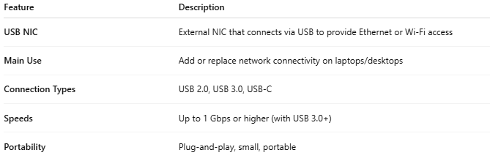

Feature | Description
USB NIC | External NIC that connects via USB to provide Ethernet or Wi-Fi access
Main Use | Add or replace network connectivity on laptops/desktops
Connection Types | USB 2.0, USB 3.0, USB-C
Speeds | Up to 1 Gbps or higher (with USB 3.0+)
Portability | Plug-and-play, small, portable

